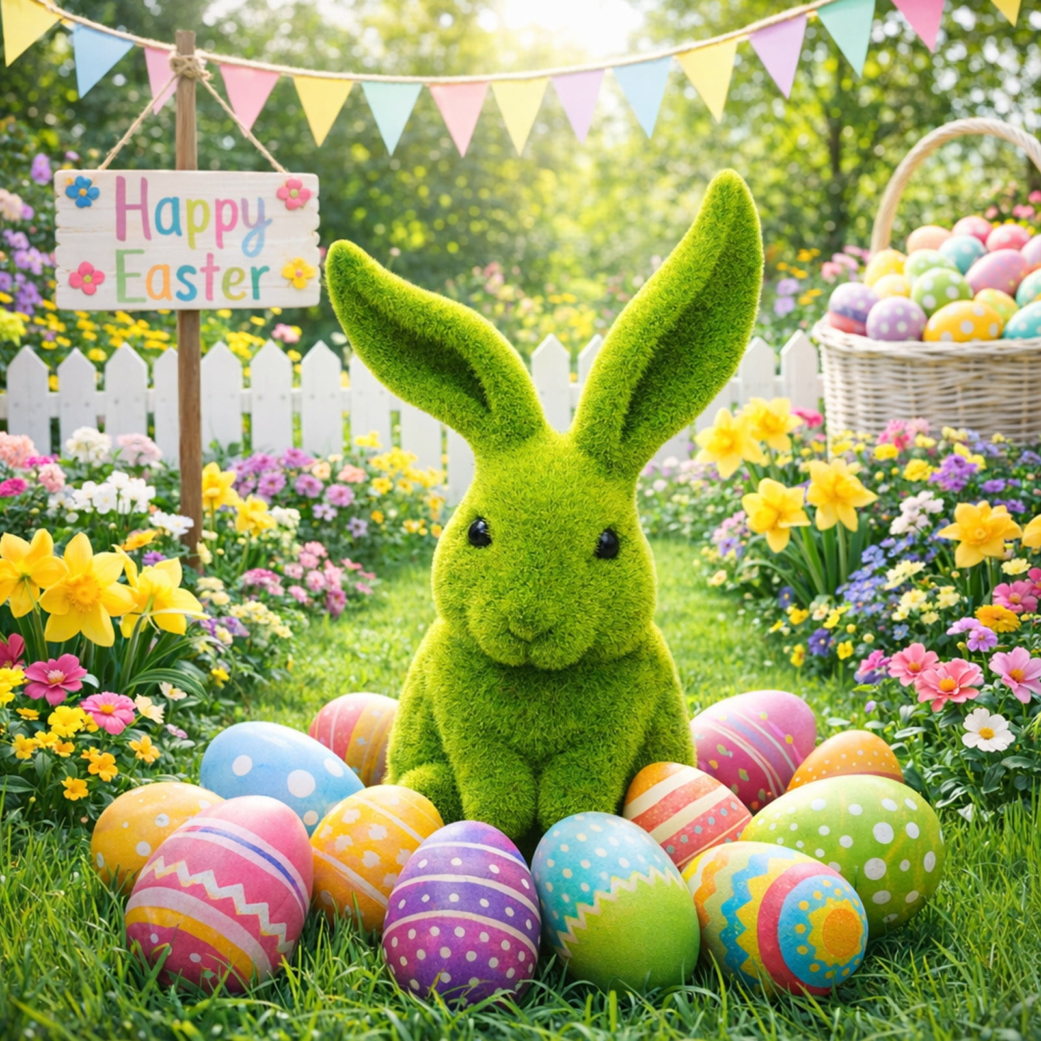
Easter Afternoon Tea

Friday 3rd April

£17.00 Adult £12.00 Child

Chicken & Bacon petite pain
Cheese & Tomato on white
Prawn Mayonnaise on brown
Sausage Roll
Shepherd’s Pie Parcel
Mini Roast Potatoes & Gravy

Mini Carrot Cake
Lemon & Lavender Posset
Rum & Raisin Fudge
Mini Egg Cheesecake
Shortbread
This Photo by Unknown Author is licensed under CC BY-NC

