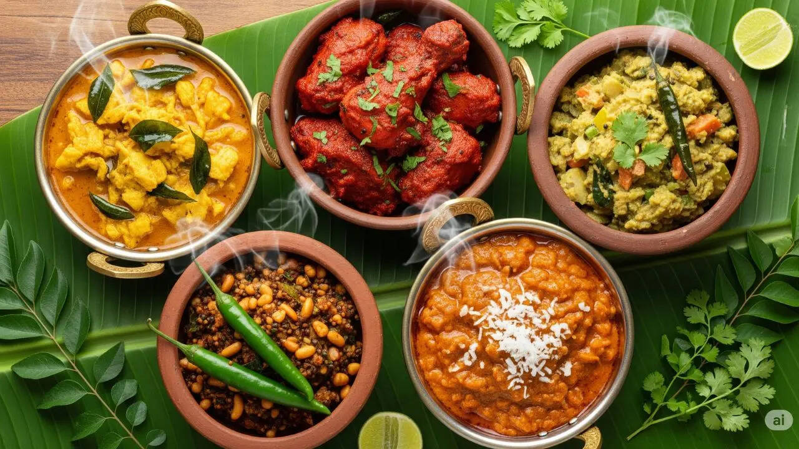
CURRY NIGHT
Friday 4th September - £21.50pp
To Begin
Onion Bhaji Loaf – Coriander & Mint Dip

Mains to Share
Chicken Madras
Tandoori Belly Pork Burnt Ends
Mid Century Southern Shrimp Curry
Gobi Manchurian
Served with Vegetable Pilau Rice & homemade Naan Bread

Desserts to Share
Chai Profiteroles
Jalebi
Mutichoor Cream Cheese Cups
Mango Lassi

