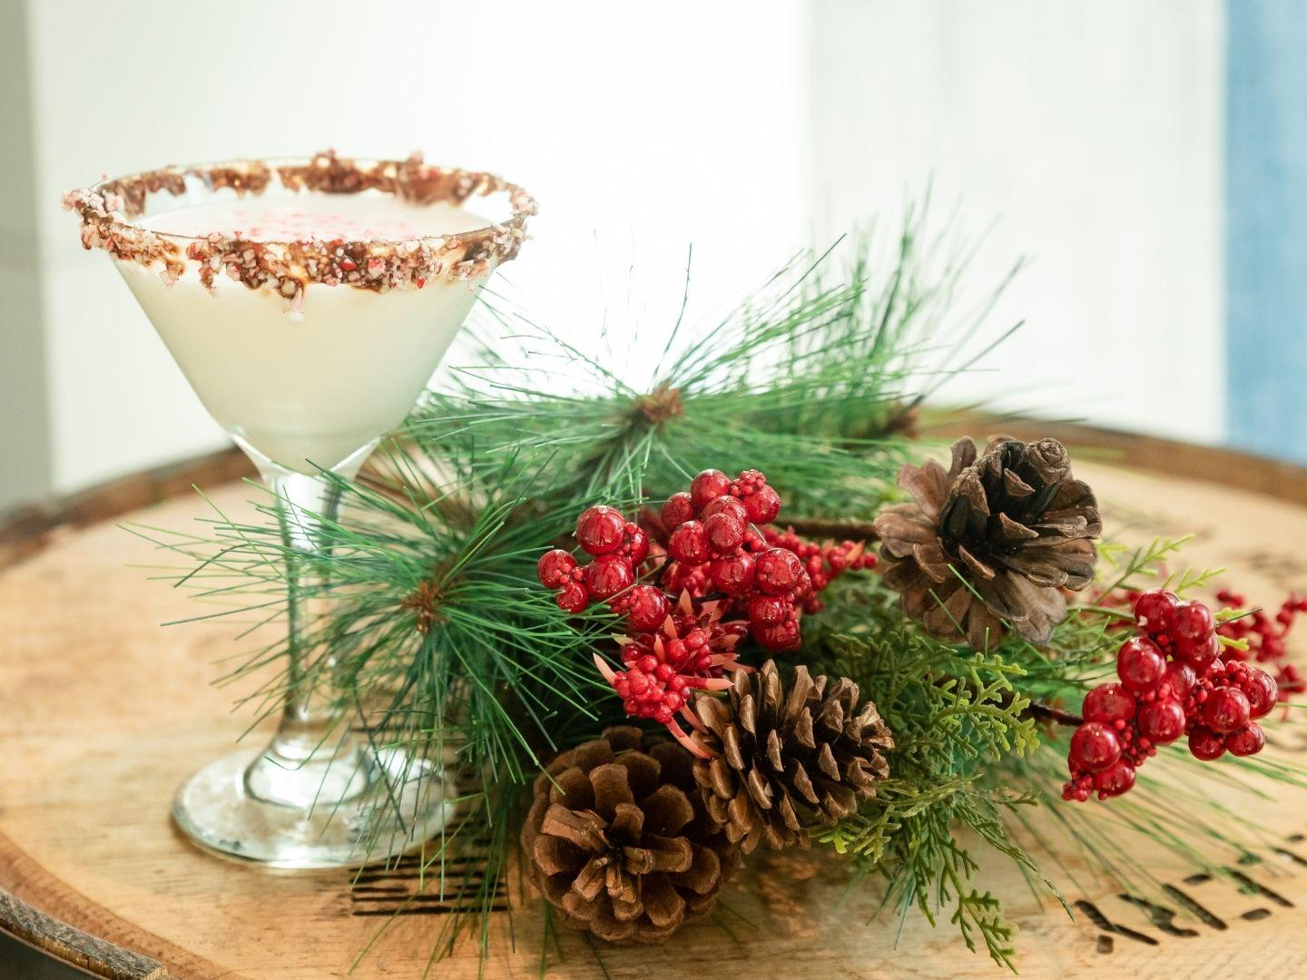
FESTIVE BRUNCH AT THE ALDER TREE
SATURDAY 20TH - £16.50pp

TURKEY, BRIE & CRANBERRY CIABATTA
Roast Potatoes, Gravy
THE BIG BREAKFAST
Bacon, Sausage, Grilled Tomato, Field Mushroom, Hash Brown, Baked Beans, Toast
SALMON & PRAWN RISOTTO
Garlic Bread
VANILLA WAFFLES
Whipped Cream, Mixed Berries, Honey
GOATS CHEESE & BEETROOT TOASTED SANDWICH
Toasted Door Stop Bread, Chips, Salad Garnish, Sweet Chilli Dressing
CHORIZO, NEW POTATO & PEA FRITTATA
Side Salad

BUCKS FIZZ & CHOICE OF HOT DRINK

