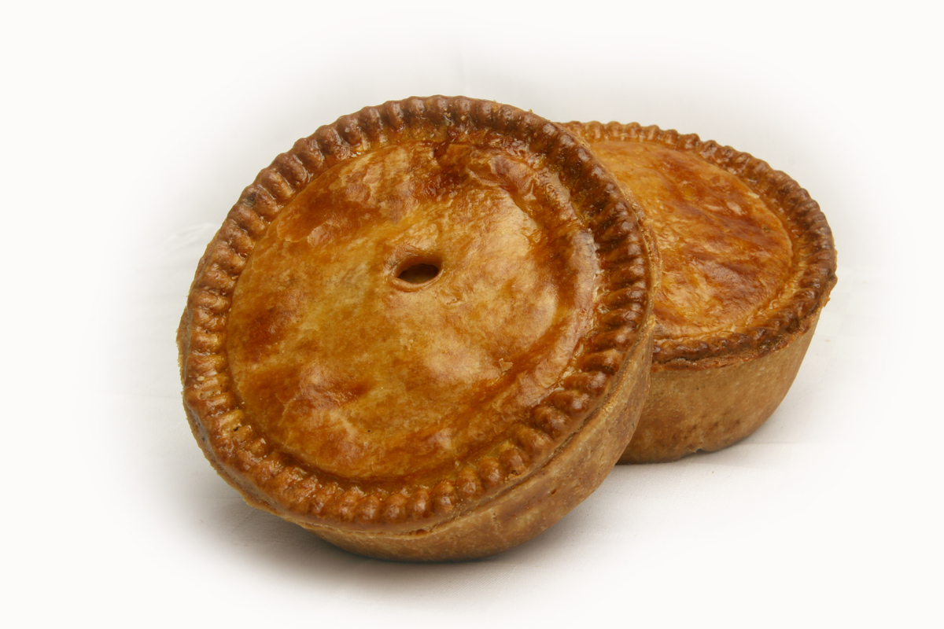
Pie Night
Friday 27th November - £21.50pp

Sharing Mains
Burger Puff Pie – beef burger, bacon, cheese and gherkin salsa
Indian Spiced Gala Pie – pork & boiled egg, spiced pastry, curry sauce
Chicken, Ham Hock & Leek – suet pastry

All served with fries, mash & mixed vegetable

Sharing Desserts
Banoffee Pie
Mississippi Mud Pie
Apple & Cinnamon Crumble Pie
Key Lime Pie Ice Cream

