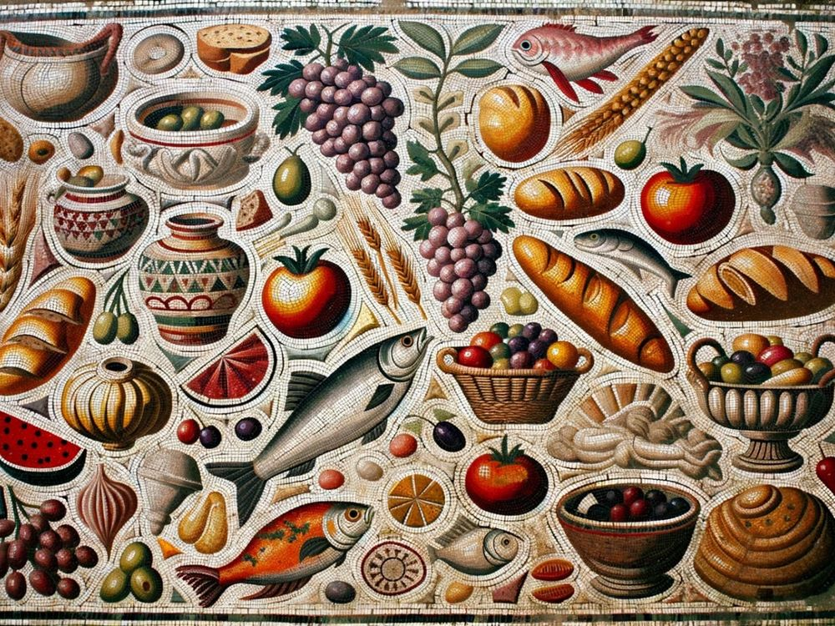

Roman Banquet Menu
Wednesday November 12th ~ £24.95pp

GUSTATIO
Phakoptisana; Ricotta, Mushroom & Endive,
Lobster & Egg, Goats Cheese, Pecorino, Olives

PRIMA MENSA
Krea Tareikhera, Psoai, Vignarola,
Pullum Parthicum, Panis Quadratus

SECUNDA MENSA
Aliter Dulcia, Libum,
Enkythoi, Pomum

