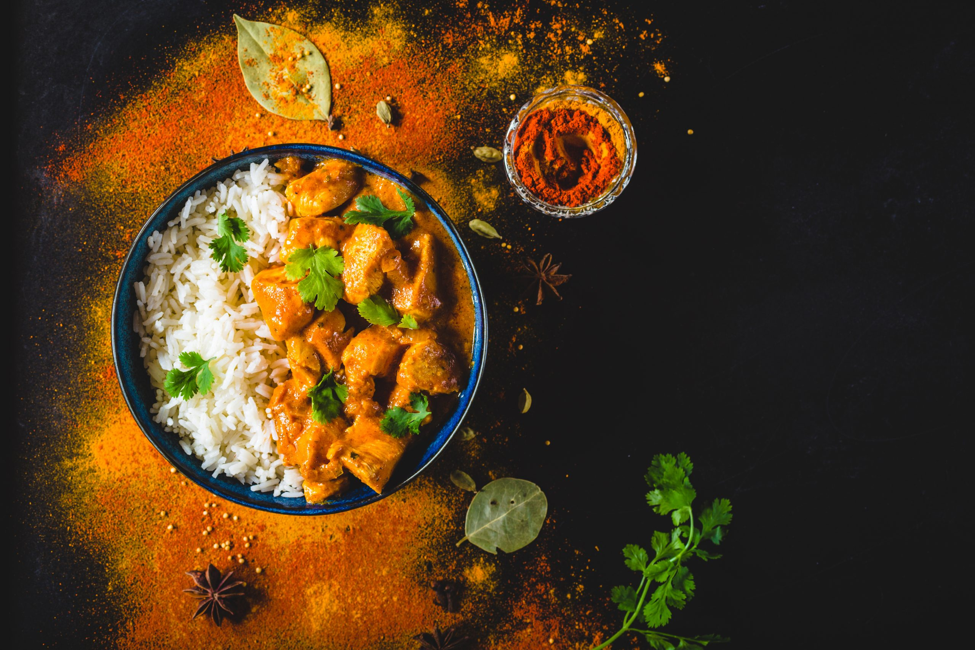
CURRY NIGHT

Friday 21st November
Starter & Main - £18.95

Sharing Starters
Paneer Tikka Kebabs, Bang Bang Gobi, Vietnamese Meatballs, Prawn Wontons, Prawn Crackers, Tamarind Chutney

Sharing Mains
Sticky Braised Belly Pork
Goan Beef Vindaloo
Chicken Darjeeling
Kung Pao Fish
Mushroom Rice, Kachumber Salad,
Taiwanese Braided Scallion Bread

Desserts from the fridge – from £6

