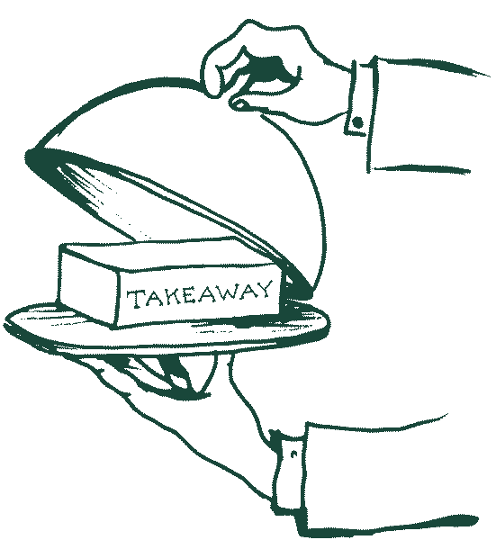
Fake Away Night
Saturday 11th April - £19.50pp

Cheesy Garlic Bread Tear & Share, Hot Honey Halloumi Sticks,
Nachos – Sour Cream, Salsa, Guacamole, Tempura Onion Petals

xxxxxxxxxx

Turkey Doner Meat Pitta, CFC, Crispy Fish Taco,
Chorizo & Mozzarella Cauliflower Pizza, Pork & Apple Slider
Dirty Fries, Coleslaw, Salad

